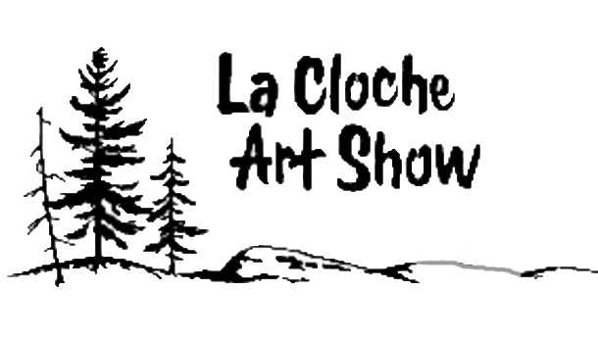

47th Annual Show
June 27th – July 4th 2026
WHITEFISH FALLS COMMUNITY CENTRE, WHITEFISH FALLS, ONTARIO
You are invited to participate in the 47th Annual La Cloche Art Show. This juried show will accept work in the following eight categories; Oil, Acrylic, Watercolour, Pastel, Coloured Pencil and Drawing, Mixed Media, Photography and Sculpture.
Prizes will be awarded according to the jury’s decisions.
This year we are excited to share that Robert Potvin is our Distinguished Artist
June 26th 2026 is Artists Night
We will begin the evening with an Artist Demonstration by Robert at 5:00 p.m. followed by a Wine and Cheese Social at 6:00 p.m.
Our Awards Ceremony will take place at 7:00 p.m.
To pre-register please complete the entry form online/or print and send e-transfer to laclocheartshow@hotmail.com CHEQUES NO LONGER ACCEPTED
Pre-registration alleviates the congestion and waiting time for artists who submit their work.
ENTRY FEE FOR ALL PARTICIPANTS IS $30.00
Artwork, along with a brief biography, will be accepted June 5th and 6th from 1 p.m. to 5 p.m. at the Whitefish Falls Community Centre. (Limited access to building for liability reasons)
Visit our website for additional entry forms – www.laclocheartshow.com
For further information call Suzanne Miron at 613-218-4795 or email: laclocheartshow@hotmail.com

Entry Form
To pre-register please complete the entry form online/or print and send e-transfer to laclocheartshow@hotmail.com CHEQUES NO LONGER ACCCEPTED
Artwork, along with a brief biography, will be accepted June 5th and 6th from 1 p.m. to 5 p.m. at the Whitefish Falls Community Centre. (Limited access to building for liability reasons)
Pre-registration alleviates the congestion and waiting time for artists who submit their work ENTRY FEE FOR ALL PARTICIPANTS IS $30.00
Please read the Art Show Policies before entering. All artists entering the La Cloche Art Show agree to all Art Show Policies
Artist's Name: _____________________________________________________________________________________
Address: _________________________________________________________________________________________
Postal Code: ___________________ Phone Number: __________________________________________________
Email Address: ____________________________________________________________________________________
Title | Category | Framed size | Selling Price
1.
2.
3.

Entries will be accepted in the following eight categories only: Oil, Acrylic, Watercolour, Pastel, Coloured Pencil and Drawing, Mixed Media, Photography and Sculpture.
All artwork must be wire hung and ready for hanging or it will not be accepted. Exhibition quality framing or stretched canvas is required with the price, name and title on the back.
The maximum framed size of artwork accepted is 36" X 48"
Each sculpture entry must specify what the sculpture is made of.
All multi-media entries must specify what mediums have been used in the artwork.
ALL PIECES MUST BE PRICED TO SELL!
For further information email: laclocheartshow@hotmail.com or call Suzanne Miron, 613-218-4795

